Question 1:
[org 0x0100]

jmp start

subtract:
push bp
mov bp,sp
mov ax,[bp+10]
sub ax,[bp+8]
sub ax,[bp+6]
sub ax,[bp+4]

pop bp
ret 8

start:
push 0xA
push 0x1
push 0x2
push 0x2
call subtract

push 0x9
push 0x1
push 0x5
push 0x0
call subtract

mov ax,0x4c00
int 21h

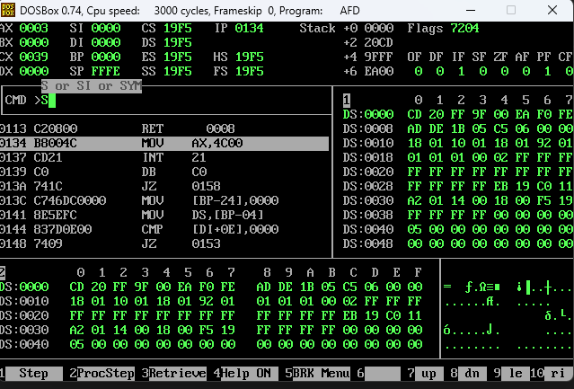
Question 2:
[org 0x0100]

jmp start

subtract:
push bp
mov bp,sp
mov ax,[bp+10]
sub ax,[bp+8]
sub ax,[bp+6]
sub ax,[bp+4]

pop bp
ret

anotherFunction:
push bp
mov bp,sp
sub sp,4

push word [bp+10]
push word [bp+8]
push word [bp+6]
push word [bp+4]

call subtract

mov word [bp-2],ax
push word[bp+4]
push word[bp+6]
push 0
push 0
;mov cx,8
call subtract
mov word [bp-4], ax
add ax, word [bp-2]
pop bx
pop bx
pop bx
pop bx
pop bx
pop bx
pop bx
pop bx
mov sp,bp
pop bp
mov bx,0
ret 8

start:
push 0xA
push 0x1
push 0x2
push 0x2
call anotherFunction

mov ax,0x4c00
int 21h

